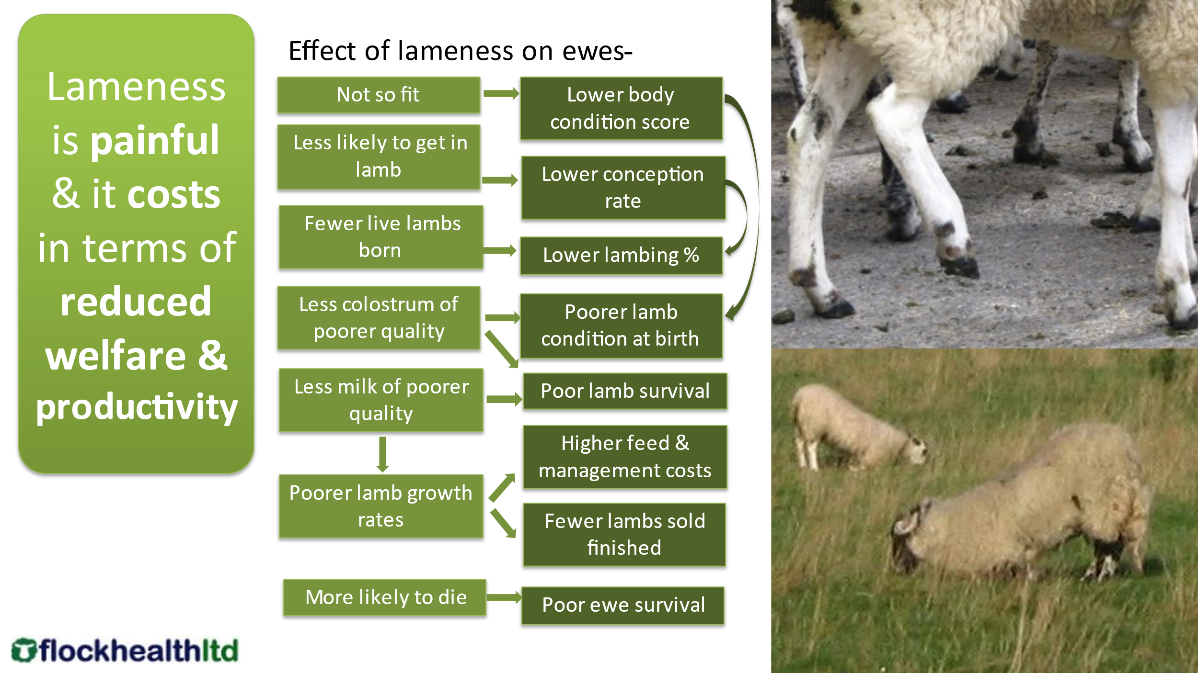

We recommend using Plan-Prevent-Protect
Plan ahead
- Get a diagnosis (use your vet)
- Do a farm-specific risk assessment
- Use the Five Point Plan
Prevent disease
- Avoid the spread of disease
- Avoid buying in CODD or new strain of footrot
  - Quarantine
- Remove risk from clinical cases
  - Treat them quickly
  - Cull when necessary
Protect the flock
- Breed in lameness-resilience
- Cull out persistently lame sheep
- Vaccinate!

The Five Point Plan
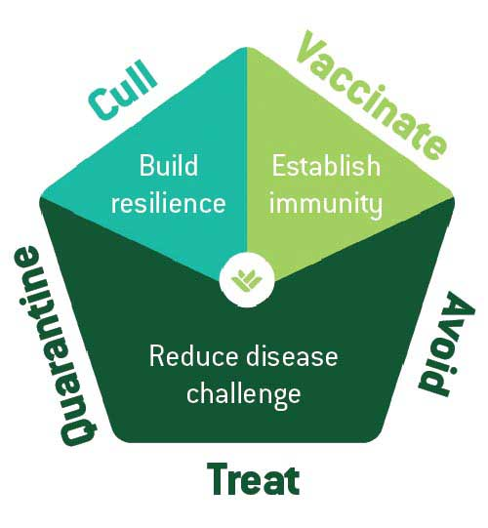
- Avoid spread of infection
- Treat individuals quickly and effectively
- Quarantine bought-in sheep
- Cull out persistent offenders
- Vaccinate to protect against foot rot

With acknowledgements to FAI Farms for the development of the Five Point Plan

Avoid- Action | Score
Do you use clean concrete in handling areas and lime/gravel/woodchip around high-traffic areas?
Do you use a clean and dry handling system?
Do you footbath according to manufacturer’s guidelines?
Do you move mineral buckets or troughs regularly?
Do you ensure all housing and pens are clean before and during lambing?
Total Score

Five Point Plan Questionnaire

Farm Name
Flock Size
Current Lameness Percentage

Quarantine- Action | Score
Do you quarantine all replacements for 4 weeks?
Do you footbath all replacements correctly?
Do you vaccinate all incoming stock for footrot?
Do you turn and inspect all incoming stock and replace any with misshapen feet?
Is all new stock bought from a known source with a low level of lameness or who are implementing the 5 point plan?
Total Score

Treat- Action | Score
Do you catch and examine lame sheep within 3 days of first observing them?
Do you mark treated sheep according to affected leg, and record ID?
Have you had the cause(s) of lameness formally diagnosed by a vet?
Have you stopped hoof trimming as a general form of treatment for lameness?
Do you use an appropriate (prescribed by your vet) antibiotic injection within 2 -3 days of diagnosing infectious causes of lameness?
Total Score

Cull- Action | Score
Do you mark, spray or tag lame sheep so they can be identified later?
Do you monitor lame ewes who have recovered for future lameness?
Do you cull if a sheep presents as lame twice despite appropriate treatment?
Do you cull out sheep with chronic misshapen feet?
Are you comfortable committing to a strict culling policy for the first year of implementing the plan?
Total Score

Vaccinate- Action | Score
Have you identified the high-risk periods of footrot on your farm?
Do you vaccinate in advance of the high risk periods at an appropriate time?
Do you vaccinate ALL your ewes and rams including replacements?
Do you ensure you use the correct dose and route by referring to the pack insert or datasheet?
Do you store your vaccine between 2°C and 8°C, and use on day of opening?
Total Score

